Features
1、Decoiler and straightener 2 in 1 machine, can improve the plant’s utilizable space.
2、The straightener adopts balance fine adjust device, suitable for process high precision products.
3、The rollers adopt the solid bearing steel and hard chrome plating treatment.
4、This equipment has three different types according to clients requirements: thin, medium and thick, can work with the related NC feeder to meet different punching requirements.

Introduction
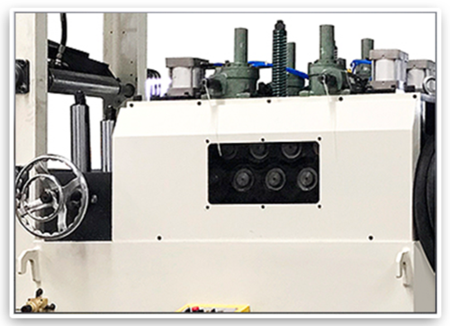
·Straightener head
- Adopt AirTAC cylinder, alloy cylinder body, hard oxidation, riveting air-tight solid aluminum, CNC precision machining, inner wall grinding smoothly, no stuck, high efficiency and high intensity operation, durable, suitable for all kinds of working conditions.
- Adopt worm gear screw lifter, the box body is made of HT200 material, the bearing is made of famous brand, with stronger impact bearing capacity and stronger durability.
- Adopt cast iron handwheel, surface electroplated, It is the most traditional handwheel.
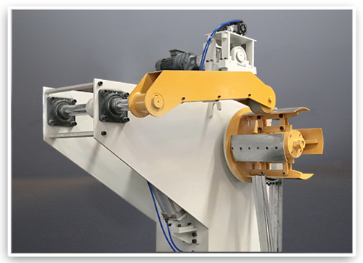

11·Frame part
The equipment adopts the integrated design of decoiler and straightener, to improve the utilization rate of the site.
Decoiler adopt cantilever beam design, all plates of the decoiler are cut by laser plasma with high precision.
All parts are processed by numerical control and CNC, with good interchangeability.
The overall structure is simple, it is convenient for general technical workers to assemble and replace, can greatly reduces the maintenance cost.
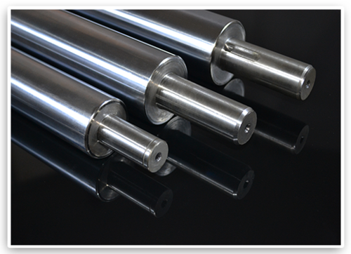
·Straightening roller
The straightening rollers are made of solid bearing steel, thickening plating treatment after medium frequency, surface hardness is not less than HRC58, to ensure material durability.
Adopt GCr15 forging round steel, after preheating treatment (spheroidal annealing), then turning, milling, intermediate frequency treatment, rough grinding and cold stabilization, then fine grinding, finally electroplating. Maximized guarantee the accuracy, concentricity, finish and hardness, and extended the using life of the rollers.
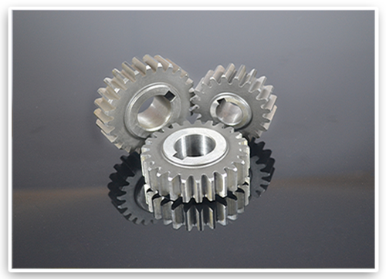
·Drive gear
Gear processing includes the following processes: gear blank processing - gear surface machining - heat treatment - gear surface fine grinding. Rough parts are mainly forging parts. Through normalizing treatment, improve the machining to facilitate cutting. According to the gear design drawings, rough machining, and then semi-finishing processing, turning, rolling, gear shaping, to make the gear basically formed. After the heat treatment to improve the mechanical properties. According to the design requirements of the drawings, finally do the finishing, finishing the benchmark, finishing the tooth profile. After all above treatments, our gear grade can reach to grade 6, with high wear resistance, high strength, long using life.
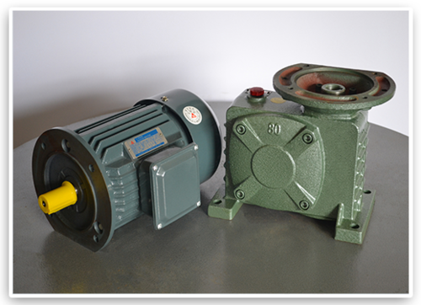
·Power part
1、Adopt model 80 worm gear vertical reducer, use the speed converter of gear , reduce the rotation number of motor to desired rotation number ,and get the mechanism with larger torque.
2、Adopt vertical motor, low vibration, low noise, stator rotor part adopt pure copper coil, life is 10 times of ordinary coil, both ends are equipped with ball bearing, low friction, low temperature.
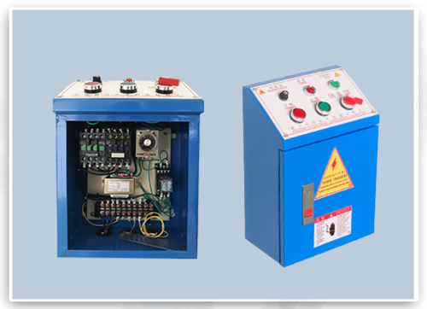
1·Electric control box
Adopt silver alloy relay, full copper coil, flame retardant safety base, long lasting and durable.
Adopt safety protection adjustment circuit time delay relay, silver alloy contact, satisfied different delay ranges.
The switch adopts sliding contact ,with self-cleaning function , normally open and normally closed contact adopts separate bonding structure, can work with different poles, equipped with anti-rotation positioning and stop loose mounting gasket.
11114、Adopt self-duplex flat button, the force is light, the key range is moderate, the building block type combination structure. The contact is made up of keto-base composite points with strong conductivity and large current, with a life span of up to 1 million times.

Specification
Model | Material width | Material thickness | Material weight | Coil inner diameter | Outside diameter | Motor | Correction rounds
TGL-300 | 300mm | 0.5~3.2mm | 2000kg | φ450-530mm | φ1200mm | 1.5kw/4p | φ60x7
TGL-400 | 400mm | 0.5~3.2mm | 3000kg | φ450-530mm | φ1200mm | 2.2kw/4p | φ60x7
TGL-500 | 500mm | 0.5~3.2mm | 3000kg | φ450-530mm | φ1200mm | 2.2kw/4p | φ60x7
TGL-600 | 600mm | 0.5~3.2mm | 3000kg | φ450-530mm | φ1200mm | 2.2kw/4p | φ60x7
TGL-700 | 700mm | 0.5~3.2mm | 4500kg | φ450-530mm | φ1200mm | 3.7kw/4p | φ60x7
TGL-800 | 800mm | 0.5~3.2mm | 5000kg | φ450-530mm | φ1200mm | 3.7kw/4p | φ60x7
TGL-300A | 300mm | 0.5~4.5mm | 2000kg | φ450-530mm | φ1200mm | 1.5kw/4p | φ75x9
TGL-400A | 400mm | 0.5~4.5mm | 3000kg | φ450-530mm | φ1200mm | 1.5kw/4p | φ75x9
TGL-500A | 500mm | 0.5~4.5mm | 3000kg | φ450-530mm | φ1200mm | 1.5kw/4p | φ75x9
TGL-600A | 600mm | 0.5~4.5mm | 3000kg | φ450-530mm | φ1200mm | 2.2kw/4p | φ75x9
TGL-700A | 700mm | 0.5~4.5mm | 4500kg | φ450-530mm | φ1200mm | 2.2kw/4p | φ75x9
TGL-800A | 800mm | 0.5~4.5mm | 5000kg | φ450-530mm | φ1200mm | 3.7kw/4p | φ75x9
TGL-300H | 300mm | 0.5~6.0mm | 2000kg | φ450-530mm | φ1200mm | 3HP | φ90x9
TGL-400H | 400mm | 0.5~6.0mm | 3000kg | φ450-530mm | φ1200mm | 5HP | φ90x9
TGL-500H | 500mm | 0.5~6.0mm | 3000kg | φ450-530mm | φ1200mm | 5HP | φ90x9
TGL-600H | 600mm | 0.5~6.0mm | 3000kg | φ450-530mm | φ1200mm | 7.5HP | φ90x9

Corrective Ability Table
Material width/ Model | TGL-300A | TGL-400A | TGL-500A | TGL-600A | TGL-700A | TGL-800A
2.5 | 300 | 400 | 500 | 600 | 700 | 800
3.0 | 300 | 400 | 500 | 600 | 700 | 800
3.5 | 300 | 400 | 500 | 500 | 550 | 600
4.0 | 300 | 400 | 400 | 400 | 400 | 420

